2. Data Engineering Foundations & Databricks

LinkedIn Article Writing Challenge

Databricks in Action: From Unity Catalog to Business Insights with SQL, Genie & AI/BI Dashboards

Day 2 Hands-On Project: Building a Retail Sales Analytics Solution
Assignment Type: Technical Blog Writing + Hands-on Implementation
Mode: Individual
Publishing Platforms: Medium or LinkedIn Articles
Dataset: Retail Sales Dataset
Final Submission: Published Blog Article + LinkedIn Post

1. The Challenge: Think Like a Data Professional
Imagine you are working as a Data Analyst for a retail company. The company collects sales data across different products, regions, sales representatives, customer types, and sales channels.
Management wants to understand:
- How much recorded sales revenue has the business generated?
- Which products and regions perform best?
- How does sales performance change over time?
- Which product categories contribute the most to recorded sales?
- Can AI help identify useful business insights?
- How can these findings be presented through an interactive dashboard?
Your task is to build an end-to-end analytics solution entirely within Databricks.
You will organize data using Unity Catalog, analyze it using Databricks SQL, explore AI-assisted analysis using Genie, and create an interactive dashboard using Databricks AI/BI Dashboards.
Finally, you will document your implementation in a technical blog and share your learning journey on LinkedIn.
This is a hands-on assignment, not just a writing task. Your article must demonstrate what you built, the queries you executed, the results you obtained, how you used Genie, and what you learned.

2. Understand Your Dataset
Use the Retail Sales Dataset shared during the session.
Column | Description
Product_ID | Identifier of the product
Sale_Date | Date of the sale
Sales_Rep | Sales representative
Region | Region where the sale occurred
Sales_Amount | Recorded sales amount for the transaction
Quantity_Sold | Number of units sold
Product_Category | Category of the product
Unit_Cost | Recorded cost per unit
Unit_Price | Recorded selling price per unit
Customer_Type | Customer classification
Discount | Recorded discount
Payment_Method | Payment method used
Sales_Channel | Channel, such as Online or Retail
Use the complete dataset for your analysis.
Data accuracy note: Use Sales_Amount as the recorded sales amount. Do not automatically recalculate it using quantity and unit price unless you have verified the dataset's calculation rules.
3. Your Implementation Tasks

Part 1: Organize the Data with Unity Catalog
Create a structured location for your sales data in Databricks.
Complete the following steps:
- Create or use the Innomatics Catalog.
- Create or use the default Schema inside that Catalog.
- Load the dataset and create a sales table.
- Check that the table contains the expected columns and records.
- Preview the data to confirm it is ready for analysis.
Your table name can be sales_dataset or another meaningful name.
Explain how a Catalog, Schema, and Table are related and why organizing data is useful.
Required evidence:
- Screenshot of the Catalog and Schema.
- Screenshot of your sales table.
- Screenshot showing sample records.
Include this structure in your article:
Innomatics → default → sales_dataset
Use your actual names if they differ.

Part 2: Answer Five Business Questions Using Databricks SQL
Act as a Data Analyst investigating the company's sales performance.
Write and execute the following five queries. For each task, include the SQL query, its output, and a short explanation of what the result tells you.

Task 1: Overall Sales Performance
Find:
- Total sales revenue.
- Total quantity sold.
- Total number of sales records.
- Number of distinct products.
Business question: What is the overall scale of the business's recorded sales?

Task 2: Top Five Products
Find the five products with the highest total sales revenue.
Display:
- Product_ID
- Total sales revenue
- Total quantity sold
Sort the results from highest to lowest revenue.
Business question: Which products contribute the most to recorded sales?

Task 3: Regional Performance
Calculate total sales revenue and total quantity sold for each region.
Sort the regions by total sales revenue, from highest to lowest.
Business question: Which regions perform best, and which may need further investigation?

Task 4: Monthly Sales Trend
Calculate total sales revenue for each month using Sale_Date.
Display the months in chronological order.
If Sale_Date is stored as text, convert it to a proper date type before performing the analysis.
Business question: How does recorded sales revenue change over time?

Task 5: Product Category Contribution
Calculate total sales revenue for each product category and its percentage contribution to overall sales revenue.
Sort the categories from highest to lowest revenue.
Business question: Which product categories contribute most to recorded sales?

SQL Requirements
- Execute all five queries in Databricks SQL.
- Capture a screenshot of each query and its result.
- Explain the main logic of each query in your own words.
- Write one or two sentences interpreting each result.
- Use the complete dataset and check whether your results are reasonable.
Keep your explanations concise and focused on the business purpose of each query.

Part 3: Use Genie for AI-Assisted Business Analysis
Use Databricks Genie, where available, to explore the sales data by asking questions in natural language.
The objective is to understand how AI-assisted analysis can help answer business questions and how its results can be validated using SQL.

Task 1: Ask Genie Business Questions
Ask Genie at least three questions from the following list:
- Which five products generated the highest total sales revenue?
- Which region generated the highest recorded sales revenue?
- How did sales revenue change month by month?
- Which product category contributed the most to total sales?
- Which sales channel generated the highest recorded sales revenue?
You may ask additional questions based on your own observations.

Task 2: Validate Genie Results Using SQL
Choose at least two questions that you have also answered using your manually written SQL queries.
For each question:
- Record the prompt you entered in Genie.
- Capture the generated SQL or analytical response, where available.
- Capture the result returned by Genie.
- Compare the result with your manually written SQL result.
- Explain whether the results match. If they differ, investigate the possible reason.
Important: Do not assume that an AI-generated query is correct without checking it against your data and business question.

Task 3: Identify a Business Insight
Identify at least one useful observation from your Genie analysis.
For example, your analysis might reveal that one region generates more recorded sales revenue than others or that a particular category contributes a large share of sales.
Use your actual results. Do not invent findings.
Required evidence:
- Screenshot of your Genie prompts.
- Screenshot of the generated SQL or response, where available.
- Screenshot of the results.
- A short comparison between Genie and your SQL analysis.
If Genie is unavailable in your environment, continue with the remaining tasks and explain the limitation in your article.

Part 4: Build a Dashboard Using Databricks AI/BI Dashboards
Now turn your SQL analysis into an interactive dashboard using Databricks AI/BI Dashboards.
Your dashboard must be created in Databricks using your sales table and analysis results. You do not need to use Power BI or any other external dashboarding platform.
Focus on accurate analysis, clear visuals, and useful business insights.

A. KPI Cards
Create at least three KPI visualizations:
- Total Sales Revenue: Sum of Sales_Amount.
- Total Quantity Sold: Sum of Quantity_Sold.
- Distinct Products: Count of distinct Product_ID values.
Challenge: Add a fourth KPI showing the total number of sales records.

B. Required Charts
Create at least three visualizations:
- Sales by Region: Compare recorded sales revenue across regions.
- Top Five Products: Show the products with the highest recorded sales revenue.
- Monthly Sales Trend: Show how recorded sales revenue changes over time.
Challenge: Add a fourth visualization showing sales by product category.
Use appropriate chart types, aggregations, sorting, and labels.

C. Interactive Filters
Add at least two interactive filters using fields such as:
- Region
- Product_Category
- Sales_Channel
- Customer_Type
- Sales_Rep
- Payment_Method
- Sale_Date
Test your filters and confirm that they update the relevant dashboard visualizations correctly.
Challenge: Add a third filter and test how it interacts with the dashboard.

4. Write Your Technical Blog Article
Once you have completed the implementation, document your work in a technical blog.

Suggested Article Structure
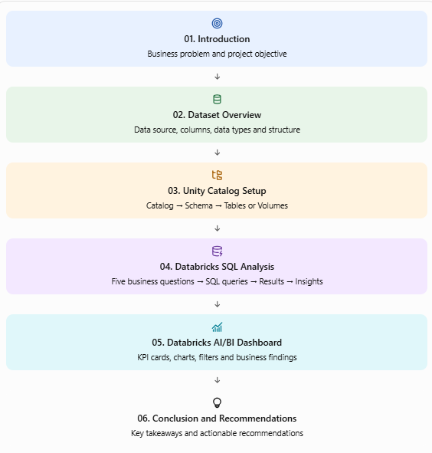

Blog Writing Guidelines
- Use clear headings and beginner-friendly explanations.
- Include screenshots from your own implementation.
- Keep SQL queries readable and properly formatted.
- Explain results in your own words.
- Clearly distinguish AI-generated suggestions from verified findings.
- Do not include passwords, access tokens, or sensitive workspace information.
- Do not copy another student's implementation or results.
Your article should demonstrate your learning, problem-solving, and ability to communicate technical work.

Step 2: Share Your Work on LinkedIn
Your LinkedIn profile is part of your professional portfolio. Use this opportunity to showcase your learning, demonstrate your technical understanding, and build your professional network.
After publishing your blog, create a professional LinkedIn post that includes:
- Blog introduction: Briefly introduce your article and explain what motivated you to explore the topic.
- Key learning: Share one important concept you learned and why it matters in the real world.
- Published blog link: Add the link to your Medium or LinkedIn Article.
- Professional tagging: Tag the following people and organization in your post. Search for their official LinkedIn profiles and select the correct accounts using LinkedIn's tagging feature.
Required tags:
- Innomatics Research Labs
Your Trainer, Mentor and Management
- Program Manager Raghu Ram Aduri | LinkedIn
- CTO — Kanav Bansal | LinkedIn
- CEO — Kalpana Katiki Reddy | LinkedIn
- Founder — Vishwanath Nyathani | LinkedIn

- Relevant hashtags: Use suitable hashtags to improve the discoverability of your post.
Suggested hashtags:
#DataEngineering #DataAnalytics #DataBricks #LearningInPublic #InnomaticsResearchLabs
Important guidelines:
- Tag the correct LinkedIn accounts rather than simply typing names as plain text.
- Keep your post professional, genuine, and focused on what you learned.
- Ensure both links are accessible before publishing.
- If an account cannot be found, verify the name with your trainer rather than tagging an incorrect profile.
Expected submission: Your published LinkedIn post URL, along with your blog URL and GitHub repository URL.
Remember: The goal is not just to announce that you completed an assignment. It is to demonstrate your learning, showcase your work, and begin building a credible professional presence in the data industry.

